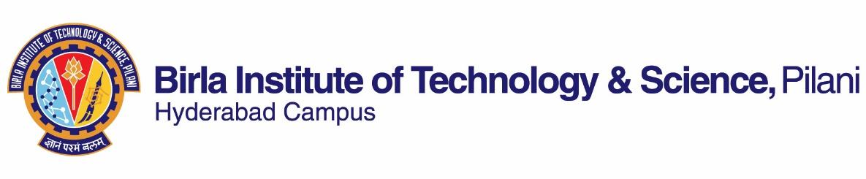

**SECOND SEMESTER 2018-2019**

# Course Handout Part II

Date: 07-01-2019

In addition to part-I (General Handout for all courses appended to the time table) this portion gives further specific details regarding the course.

*Course No.* : BITS F112

## Course Title : Technical Report Writing

## Instructor-in-Charge : Santosh Mahapatra

**Scope and Objective of the Course:** Newly admitted undergraduate students at BITS are required to learn technical report writing and academic presentation skills so that they can write and present reports for PS, LoP/DoP courses and theses effectively. Aimed at basic to intermediate level students from a variety of disciplinary backgrounds, the course focuses on general academic language needs of students. Being skilled in writing, note-making and note-taking can enable students to write and present technical reports more effectively. In addition, students are introduced to conventions of academic formatting, referencing and citation, which they would be expected to utilize while writing reports.

The main objectives of the course are to:

* improve students’ ability to read and listen to academic texts and prepare notes;
* enhance students’ academic writing skills;
* familiarize students with various aspects of technical reports;
* enable students to make academic presentations.

**Textbooks:**

1. Hewings, M. and Thaine, C. 2014. *Cambridge Academic English (Advanced) Student’s Book*. First South Asian Edition. Cambridge University Press.

**Reference Books:**

1. Peter Levrai and Averil Bolster. 2015. *Academic Presenting and Presentations: Student's Book*. BoD – Books on Demand.
2. Stephen Bailey. 2017. *Academic Writing: A Handbook for International Students*, 5th Edition, Routledge.
3. Rhonda Liss and Jason Davis. 2012. *Effective Academic Writing (The Researched Essay) 3*. Second Edition. OUP

**\*** *Relevant materials from the web will also be used.*

**Course Plan:**

|  |  |  |  |
| --- | --- | --- | --- |
| **Lecture No.** | **Learning objectives** | **Topics to be covered** | **Chapter in the Text Book** |
| 1 | Recognize different elements and aspects of the course; identify the difference between general and academic communication | Course Overview: Importance, objective, topics and assessment  Communication: general and academic | Web sources |
| 2-9 | Apply basic elements of writing academic paragraphs and differentiate among distinct kinds of paragraphs; write e-mails effectively; create concise versions of academic texts and restate academic texts in an original manner | Elements of effective writing: Words, phrases, linkers and appropriate sentence structures, paragraph writing, e-mail writing, summarizing and paraphrasing | T1 Unit 1, 2  and  R2. Part I & II |
| 10 | Discover different types and aspects of technical reports | Understanding formal reports, types of reports; academic reports | Web sources |
| 11-15 | Utilize various preparatory steps to report writing; develop outlines, organize and prepare notes | Preparatory steps for writing reports: Reading short articles, reports and making notes, listening to presentations/lectures and taking notes | T1. Units 1, 2, 5, 9, 10, Lecture skills C, D |
| 16-25 | Evaluate the content and language of each section of a report | Structure of reports and method and sources of data: Abstract/executive summary; title and contents pages; introduction; methods; results; discussion and conclusion; references | T1. Units 5-10, web sources |
| 26-29 | Develop an outline for a presentation; select and use appropriate technological tools, list the components, select content and utilize appropriate language | Oral presentation and use of illustrations: Structure, outline, delivery modes, body language and voice, visual aids | T1. Unit 4-10  R1 and web sources |

**Evaluation Scheme:**

|  |  |  |  |  |
| --- | --- | --- | --- | --- |
| **Component** | **Duration** | **Weighting (%)** | **Date & Time** | **Nature of Component** |
| Assignment 1 |  | 15% |  |  |
| Mid-semester Examination | 90 minutes | 30 | 11/3  9.00 - 10.30AM | Open book |
| Assignment 2 |  | 15% |  |  |
| Comprehensive Examination | 3 hours | 40 | 08/05 AN | Open book |

**Chamber Consultation Hour:** The slot will be decided during the first class.

**Notices:** Notices concerning the course will be displayed on the CMS.

**Make-up Policy:** Make-up will be given only in genuine cases (subject to verification).

**Academic Honesty and Integrity Policy:** Academic honesty and integrity are to be maintained by all the students throughout the semester and no type of academic dishonesty is acceptable.

**Santosh Mahapatra**

**INSTRUCTOR-IN-CHARGE**